|  |  |  |
| --- | --- | --- |
| **Tech Saksham**  Final Project Report  **Full Stack Web Development** |  |  |

**“Placement Management System”**

**“Rajiv Gandhi University of Knowledge Technologies, RK VALLEY”**

|  |  |
| --- | --- |
| **ROLL NO** | **NAME** |
| R171143 | Keerthivallika Jangala |
| R171142 | Jyosthna Srirangapuram |
| R171150 | Meghana Nalagatla |

|  |  |
| --- | --- |
|  | Poovaragavan Velumani |
|  | Trainer Name |
|  |  |

**ABSTRACT**

The Placement Management System, a student and company information system is a web based application that was created for making the application process easy for a job. We use XAMPP server for this application, the backend programming language is PHP, database used is SQL, and the frontend languages are HTML, CSS, Bootstrap and JS.

The main objective of the project is used to provide job opportunities to the students. It also provides the facility viewing the personal and academic information of the student. From a student’s perspective placements can bring a wide range of benefits and opportunities. System gets the requested list of the candidates for the companies who could like to recruit the people according to their eligibility criteria. It also supports insertion and deletion of records by the administrator.

The system is intended for the students and companies. Our project reduces the usage of manual work. It is user friendly because in our placement management system user no need to bother about the procedure of submitting the application for different job roles as it is easy to apply for jobs within one click.

**INDEX**

|  |  |  |
| --- | --- | --- |
| **Sr. No.** | **Table of Contents** | **Page No.** |
| 1 | Chapter 1: Introduction | 4-5 |
| 2 | Chapter 2: Services and Tools Required | 6-7 |
| 3 | Chapter 3: Project Architecture | 8 |
| 4 | Chapter 4: Architecture Blocks Detail Working | 9 |
| 5 | Chapter 5: Project Budget | 10 |
| 6 | Conclusion | 11 |
| 7 | References | 12 |
| 8 | Code | 13 |

**CHAPTER 1**

**INTRODUCTION**

* 1. **Overview**

The project involved designing a database along with its frontend and backend components to facilitate placements in the institute. The placement database management project has been made to give various access for different type of users i.e., students, administrator or placement officer and companies. Every user has his own limited set of features. The project involves use of various web and database technologies namely HTML, CSS, PHP, MySQL, etc.

The application is reduced as much as possible to avoid errors while entering the data. It also provide error message while entering invalid data. No formal language is needed for the user to use this system, it is user friendly.

Placement Management System, as described above can lead to error free, secure, reliable and fast management system. It can assist to the user to concentrate on the placement records keeping.

This is designed to assistent strategic planning and will help you to ensure that your organization is with the right information and details for future goals. These system allow you to better manage placement records.

* 1. **Features**

**Admin Module:** Placement Officer is the administrator of the system. Admin plays a very crucial role in the system. Admin can log in through a username and password. Admin can maintain the placement activities via the system, admin can delete the drives. Admin can manage everything on the website.

**Candidate Module:** Candidate is refered as student who are registered into website and logged into website. They can apply for jobs based on their skills.

**Company Module:**

Company can registered the website and logged into website, company can post jobs and recruit students.

* 1. **Advantages**

Placement management system allows students to apply jobs for different companies, allows companies to recruit students. Easy to use the website. It is easier for placement officer to manage all placement related data. It is used for knowing the status of students performance.

* 1. **Scope**

The main objective of the Placement Management System is to manage the details of the Student and Placement Cell, to reduce manual work and time. To offer recruitment to applicants. It handles all the data about skills of a student Placement Cell. The project is totally built at the main users end and thus the users can be accessed valid by login ID and password.

**CHAPTER 2**

**SERVICES AND TOOLS REQUIRED**

**2.1 Tools and Softwares used**

|  |  |
| --- | --- |
| **Frontend** | HTML, CSS, bootstrap, JS |
| **Backend Language** | PHP |
| **Database Server** | MySQL |
| **Web Browser** | Chrome, firefox |
| **Operating System** | Ubuntu, windows |
| **Server** | Xampp |

**2.1.1 HTML :**  HTML is the standard markup language for documents designed to be displayed in a web browser.

**2.1.2 CSS :**  Cascading Style Sheets is a style sheet language used for describing the presentation of a document written in a markup language such as HTML or XML.

**2.1.3 JavaScript :** JavaScript is a scripting language that enables you to create dynamically updating content, control multimedia, animate images, and pretty much everything else.

**2.1.4 Bootstrap :** Bootstrap is a free, open source front end development framework for the creation of websites and web apps. Designed to enable responsive development of mobile first websites, Bootstrap provides a collection of syntax for template designs.

**2.1.5 PHP :** PHP is a recursive acronym for "PHP: Hypertext Preprocessor". PHP is a server side scripting language that is embedded in HTML. It is used to manage dynamic content, databases, session tracking, even build entire e-commerce sites.

**2.1.6 MySQL :** MySQL is a relational database management system The database structure is organized into physical files optimized for speed. The logical data model, with objects such as data tables, views, rows, and columns, offers a flexible programming environment.

**CHAPTER 3**

**PROJECT ARCHITECTURE**

**3.1 Architecture**

**USER FRONTEND BACKEND**

|  |  |  |
| --- | --- | --- |
|  | **HTML, CSS, JS, Bootstrap** | **PHP**  **MySQL**  **Database** |
|  |  |  |

**CHAPTER 4**

**ARCHITECTURE BLOCKS DETAIL WORKING**

**4.1 Blocks**

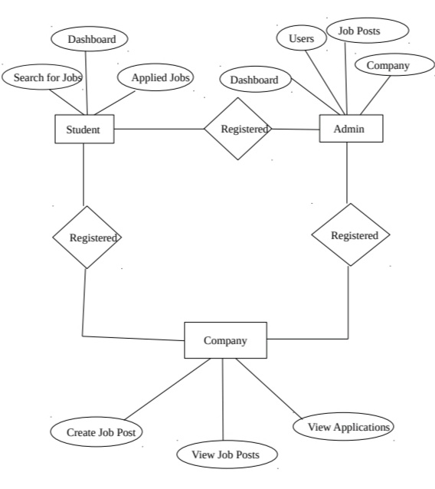

**CHAPTER 5**

**PROJECT BUDGET**

**This project is build by taking reference from different websites and with the help of trainer. No external resourced were bought to complete the project**

**CONCLUSION**

In the existing system most of the the work will be done manually, as it takes more time for any changes in the system. The major problem with this existing system are notification method available is not available for giving information about student expect the notice board or circulars. The proposed system is online training and placement management system gives the automation in all the process of campus recruitment, searching student details individually.

**REFERENCES**

<https://www.w3schools.com/css/>

<https://www.w3schools.com/html/>

<https://www.w3schools.com/PHP/>

<https://www.w3schools.com/bootstrap/>

<https://www.geeksforgeeks.org/>

**CODE**

[**https://github.com/keerthivallika/Placement_Management_System**](https://github.com/keerthivallika/Placement_Management_System)